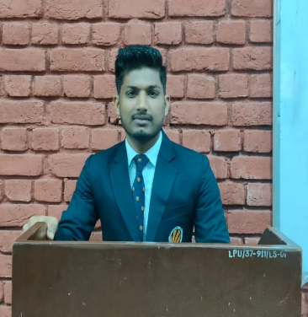



+91 9523309855

RUPAM TIWARY

ASPIRING FULLSTACK DEVELOPER

Rupamtiwary365@ g mail.com

[www.linkedin.com/in/r-wart](http://www.linkedin.com/in/r-wart)

Phagwara, Punjab

rwart8878

SUMMARY

Aspiring engineer driven by passion who loves solving problems in software domain and constantly looking for opportunity that challenge and push his limits.

TECHNICAL SKILLS

Programming languages: Java, C++

Python

Web Technologies:

Reactjs, HTML5, CSS, Bootstrap,

Expressjs, Nextjs,

Nodejs, Javascript, Tailwindcss

Data Management:

MySQL, MongoDB, MS Access

Tools: Git, Github, Firebase

Expertise: Data structure and Algorithm

OS , CLOUD , OOPS , NETWORKING

CERTIFICATIONS

INTERNSHIP

## 

Student Counselor Jun'22 - Jul '22

Lovely Professional University | Phagwara, IN

Guided more than 1,000+ student in tech related domain

Gained hands-on experience in understanding the admission process, also understand complete tech stack and requirement of technologies.

Placement Coordinator

Conducted more than 15+drive got to know more about the companies and their requirements.

PROJECTS

# 

Movie Search App Jun'22

Domain: Application | Reactjs

Constructed an application to get the information of movie rating Developed features for the application and created a new landing page to enhance customer experience

Utilized all redux tool, react carsouel , build skeleton while loading

File Sharing App Mar'22

Domain: JavaScript Nodejs Express MongoDb | Programming

Unique link get generated.

Upgraded code to make the error-free

Created HTML, CSS, JavaScript, and JSP pages for user interaction Virtual Card Generator

Frontend Development | The Infinity Board | Jun'23 Reactjs Development| Cipher School | Jan ‘22

Domain Web Development | Html | css | javascript

Build for generating virtual card debit or credit according to input

Links

## 

POWER SKILLS

# 

Adaptive

Team Player

Pressure Handler

Quick Learner

Leetcode- https://leetcode.com/_rwart/

Codechef-https:/[/www.codechef.com/users/rwart](http://www.codechef.com/users/rwart) Github-https://github.com/rwart8878

EDUCATION

## 

B.Tech. in Computer Science Apr '20 – Present Lovely Professional University | Phagwara, IN

Higher Secondary Jun '14 - Mar '19

EXTRA CURRICULAR ACTIVITIES

Won district level volleyball competition.

Dav Rb Kedia High School |

Birgunj,Nepal 90.80% 10th Dav Rb Kedia School Birgunj,Nepal CGPA 10